Using Autograph – Alternate Segment Theorem

page-new 2d 24 h p Open Autograph in Standard Level.

axes-edit 24 h p Edit Axes and remove the axes, grid and key (under “Options” tab).

Click the 0.1 Snap Settings.



mode-point 24 h p Draw a point in roughly the middle of the page.

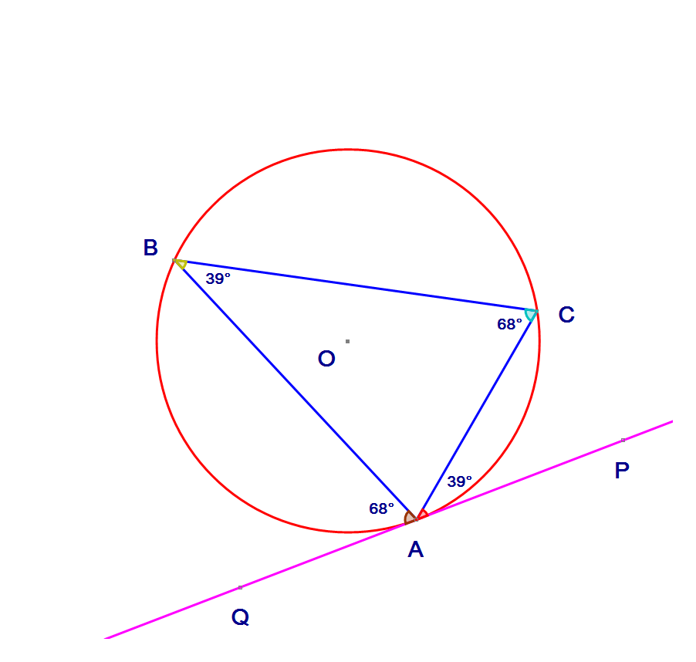 Select the point and right click to add a “Circle (Radius)…”. In the dialogue box give it a radius of 2.5.



Add three points on the circle.



Join point A to point B by selecting the points, right clicking and choosing “Line Segment”. Also join point A to point C. Join point B to point C.



Description: Description: Description: Description: Cursor Select point A, and right click to add “Tangent”.

Select points A, B and C (in that order) and right click to add “Angle…”. Click OK in the dialogue box. Do the same for A, C and B (in that order).



Add two points on the tangent, either side of A.



Description: Description: Description: Description: Cursor Add the “Angle…” QAB and PAC.

Write ***in your own words*** about the connection between the angles in the alternate segments.