Using Autograph – Intersecting Tangents

page-new 2d 24 h p Open Autograph in Standard Level.

axes-edit 24 h p Edit Axes and remove the axes, grid and key (under “Options” tab).

Click the 0.1 Snap Settings.



mode-point 24 h p Draw a point in roughly the middle of the page.

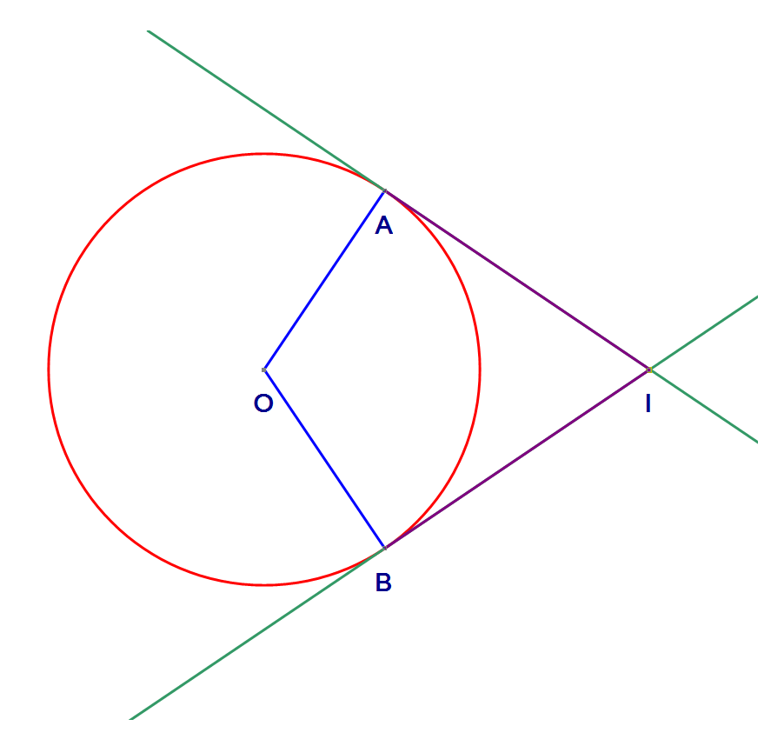 Select the point and right click to add a “Circle (Radius)…”. In the dialogue box give it a radius of 2.5.



Add two points on the circle.



Join point A to the centre O by selecting the points, right clicking and choosing “Line Segment”. Also join point B to the centre O.



Select point A and right click to add “Tangent”. Do the same for point B.



Select the two tangents and right click and “Solve Intersection”.



Description: mode-point 24 h p Add a point on the intersection.

Description: Description: Description: Description: Cursor Add “Line Segment” between A and I and B and I, and add a text box to show the length.

Write ***in your own words*** about the connection between the intersecting tangents.